

**EXPERIMENT NO:03**

**Aim:** Sketch the UML Use Case Diagram for the project

**Tools:** IBM Rational Rose

**Theory:** In the Unified Modelling Language (UML), a use case diagram can summarize the details of your system's users (also known as actors) and their interactions with the system. To build one, you'll use a set of specialized symbols and connectors. An effective use case diagram can help your team discuss and represent:

* Scenarios in which your system or application interacts with people, organizations, or external systems
* Goals that your system or application helps those entities (known as actors) achieve
* The scope of your system

A use case diagram doesn't go into a lot of detail—for example, don't expect it to model the order in which steps are performed. Instead, a proper use case diagram depicts a high-level overview of the relationship between use cases, actors, and systems. Experts recommend that use case diagrams be used to supplement a more descriptive textual use case.

UML is the modelling toolkit that you can use to build your diagrams. Use cases are represented with a labelled oval shape. Stick figures represent actors in the process, and the actor's participation in the system is modeled with a line between the actor and use case. To depict the system boundary, draw a box around the use case itself.

UML use case diagrams are ideal for:

* Representing the goals of system-user interactions
* Defining and organizing functional requirements in a system
* Specifying the context and requirements of a system
* Modelling the basic flow of events in a use case
* **Use case diagram components:**
* **Actors:** The users that interact with a system. An actor can be a person, an organization, or an outside system that interacts with your application or system. They must be external objects that produce or consume data.
* **System:** A specific sequence of actions and interactions between actors and the system. A system may also be referred to as a scenario.
* **Goals:** The end result of most use cases. A successful diagram should describe the activities and variants used to reach the goal.
* **Use case diagram symbols and notation**

The notation for a use case diagram is pretty straightforward and doesn't involve as many types of symbols as other UML diagrams. You can use this guide to learn how to draw a use case diagram if you need a refresher. Here are all the shapes you will be able to find in Lucid chart:

* **Use cases:** Horizontally shaped ovals that represent the different uses that a user might have.
* **Actors:** Stick figures that represent the people actually employing the use cases.
* **Associations:** A line between actors and use cases. In complex diagrams, it is important to know which actors are associated with which use cases.
* **System boundary boxes:** A box that sets a system scope to use cases. All use cases outside the box would be considered outside the scope of that system. For example, Psycho Killer is outside the scope of occupations in the chainsaw example found below.
* **Packages:** A UML shape that allows you to put different elements into groups. Just as with component diagrams, these groupings are represented as file folders.
* **UML Use Case Diagram for our Project:**

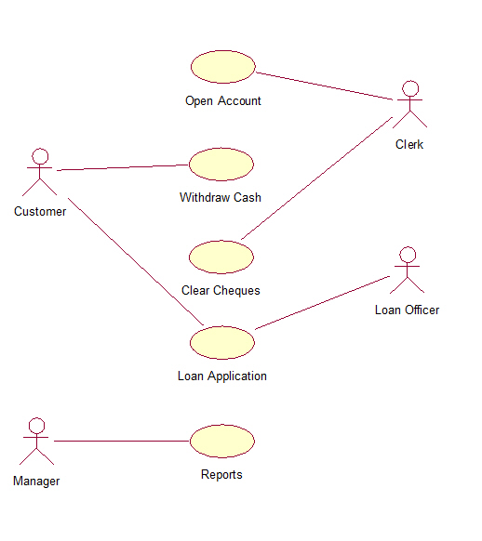

**Conclusion:**

A use case diagram is drawn to capture the functional requirement insoftware development. It also shows the interactions between requirements are actors. But,use case diagram never describes how they are implemented. It only shows the flow of theproject.

ForFacultyUse

|  |  |  |  |  |
| --- | --- | --- | --- | --- |
| **CorrectionParameters** | **FormativeAssessment[40%]** | **Timely completionofPractical[40%]** | **Attendance /LearningAttitude[20%]** |  |
| **MarksObtained** |  |  |  |